Set 7: Customer Demographics Analysis
Field | Details
Department | AIDS
Course Code / Course Name | DSA0602 / Data Handling and Visualization
Experiment | Data Visualization using R
Name | B Mallika
Register Number | 192324234
Date | 03-10-2026
Day | Saturday

Aim
To visualize customer age and gender distributions, display customer demographic information in a table, and design an interactive dashboard for demographic exploration.
Dataset: Customer Demographics
Customer ID | Age | Gender | Income ($)
1 | 28 | Female | 50000
2 | 35 | Male | 60000
3 | 42 | Female | 75000

PROGRAM 1: Bar Chart of Customer Ages
Create a bar chart to visualize the distribution of customer ages. Label the axes and title the chart.
# Dataset
customer_id <- c(1, 2, 3)
age <- c(28, 35, 42)
# Bar Chart
barplot(age,
names.arg = customer_id,
xlab = "Customer ID",
ylab = "Age (Years)",
main = "Age Distribution of Customers",
col = "skyblue")
Output 1: Bar Chart of Customer Ages
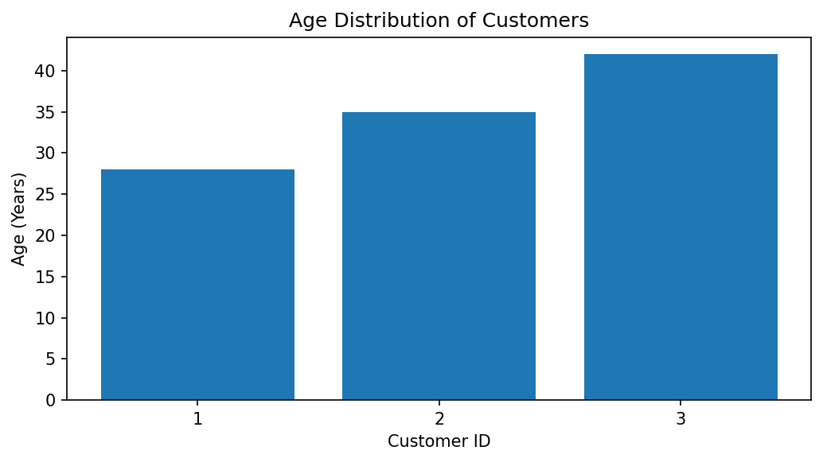
Observation: The chart displays the ages of the three customers. Customer 3 is the oldest at 42 years, while Customer 1 is the youngest at 28 years.

PROGRAM 2: Pie Chart of Customers by Gender
Generate a pie chart to represent the distribution of customers by gender.
# Dataset
gender <- c("Female", "Male", "Female")
# Calculate gender frequency
gender_count <- table(gender)
# Pie Chart
pie(gender_count,
labels = paste(names(gender_count), gender_count),
main = "Customer Distribution by Gender",
col = c("pink", "skyblue"))
Output 2: Pie Chart of Customers by Gender
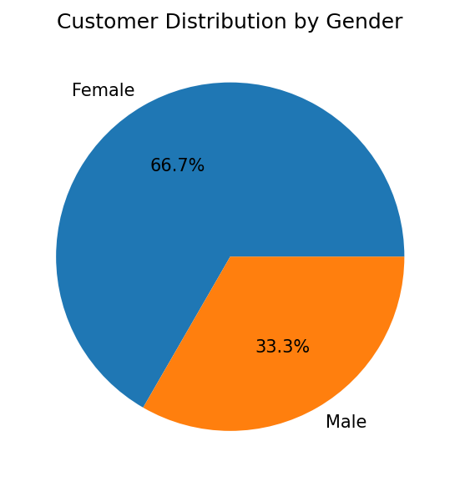
Observation: Two customers are Female and one customer is Male. Therefore, Female customers represent 66.7% and Male customers represent 33.3% of this sample.

PROGRAM 3: Table of Customer Demographic Information
Build a table to show the demographic information for each customer. Label the table elements.
# Create demographic dataset
customer_data <- data.frame(
Customer_ID = c(1, 2, 3),
Age = c(28, 35, 42),
Gender = c("Female", "Male", "Female"),
Income = c(50000, 60000, 75000)
)
# Display table
print(customer_data)
Output 3: Table of Customer Demographic Information
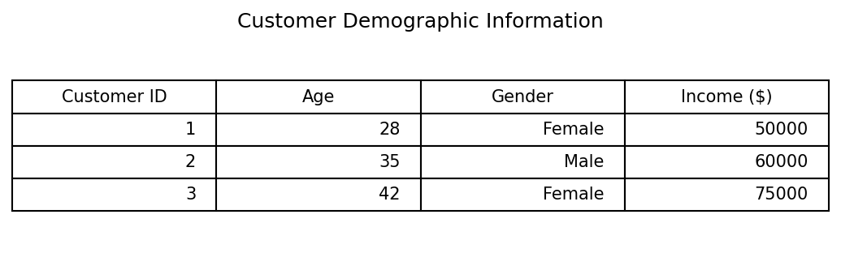
Observation: The table displays Customer ID, Age, Gender, and Income for all three customers.

PROGRAM 4: Interactive Customer Demographics Dashboard
Develop a Tableau dashboard combining the bar chart, pie chart, and the table for interactive exploration of customer demographics.
# Tableau dashboard steps
# 1. Connect to the Customer Demographics data.
# 2. Create a bar chart: Customer ID on Columns and Age on Rows.
# 3. Create a pie chart: Gender on Color and Number of Records on Angle.
# 4. Create a text table with Customer ID, Age, Gender, and Income.
# 5. Add all three worksheets to a new Dashboard.
# 6. Add Gender and Age filters and apply them to the required views.
# 7. Add dashboard actions so selecting a chart filters the other views.
# R code to prepare and inspect the same source data:
customer_data <- data.frame(
Customer_ID = c(1, 2, 3),
Age = c(28, 35, 42),
Gender = c("Female", "Male", "Female"),
Income = c(50000, 60000, 75000)
)
print(customer_data)
Output 4: Interactive Customer Demographics Dashboard
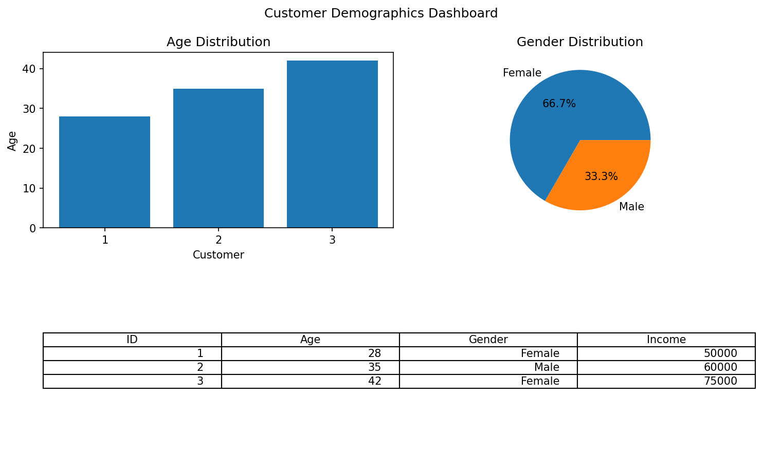
Observation: The Tableau dashboard combines the age bar chart, gender pie chart, and demographic table. Filters allow users to explore the available customer records.
Procedure
Create vectors for customer ID, age, gender, and income.
Use barplot() to visualize customer ages.
Use table() and pie() to display the gender distribution.
Create a data frame and print it to display demographic information.
In Tableau, create the three worksheets, combine them in a dashboard, and add interactive filters.
Result
The customer demographic data was visualized successfully using a bar chart and pie chart. A demographic table and an interactive Tableau dashboard layout were also prepared.
Key R Functions Used
Function | Purpose
barplot() | Creates a bar chart.
table() | Calculates category frequencies.
pie() | Creates a pie chart.
data.frame() | Combines variables into a data frame.
print() | Displays the data frame.

